# **Project: Summarizing and Analyzing Research Papers**

**Learner Name**: Sundram Kumar Ray

**Learner Email**: sundramraycse@gmail.com

**Topic**: **Engineering**: Summarize and analyze research on advancements in renewable energy technologies.

**Research Paper:**

* **Title**: *Energy-Sustainable IoT Connectivity: Vision, Technological Enablers, Challenges, and Future Directions*
* **Source**: IEEE Xplore
* **Link**: [Energy-Sustainable IoT Connectivity](https://ieeexplore.ieee.org/stamp/stamp.jsp?tp=&arnumber=10285066)

The paper delves into the future of IoT (Internet of Things) connectivity from the perspective of energy sustainability. It explores technological enablers that make energy-sustainable IoT possible, outlines major challenges, and suggests future directions in the field. It emphasizes the need for advancements in low-power communication, energy harvesting, and adaptive machine learning algorithms to enable scalable, energy-efficient IoT networks.

**Prompts and Iterations:**

1. **Initial Prompt**:
   * **Prompt**: *"Summarize the research paper on energy-sustainable IoT connectivity, focusing on key challenges and future directions."*
   * **Generated Summary**: The IoT is transforming industries, but energy sustainability remains a challenge. The paper identifies several technological enablers, including energy-efficient protocols and hardware improvements. It also discusses the challenges of scalability, power management, and energy harvesting in future IoT networks.
2. **Refined Prompt 1**:
   * **Prompt**: *"Provide a detailed summary of the technological enablers discussed in the research paper on energy-sustainable IoT connectivity."*
   * **Generated Insights**: The paper emphasizes the importance of advanced hardware and communication protocols for achieving energy sustainability in IoT systems. Key enablers include LPWANs (Low Power Wide Area Networks), energy harvesting from ambient sources, and optimized sensor designs. These technologies are critical for reducing the power consumption of IoT devices, allowing them to operate efficiently over long periods without needing frequent battery replacements.
3. **Refined Prompt 2**:
   * **Prompt**: *"Analyse the future directions and challenges mentioned in the research paper concerning renewable energy's integration into IoT connectivity."*
   * **Generated Insights**: Future research will focus on improving the integration of IoT systems with renewable energy sources. This includes advancements in energy storage, adaptive machine learning algorithms that can predict and optimize power usage, and distributed energy management systems that scale with increasing IoT deployment. The challenges lie in ensuring that IoT devices can operate reliably within these dynamic and decentralized energy environments.
4. **Refined Prompt 3**:
   * **Prompt**: *"What are the challenges mentioned in scaling IoT systems with renewable energy integration, and how are these addressed in the research paper?"*
   * **Generated Insights**: Scaling IoT systems with renewable energy integration introduces challenges related to energy storage, intermittent power supply, and load balancing across large-scale networks. The research paper highlights the use of distributed computing and real-time optimization algorithms as key strategies to mitigate these challenges. Techniques like decentralized AI and machine learning-driven power optimization are being explored to ensure reliable IoT operation in fluctuating energy conditions.

**Generated Summaries and Insights:**

**First Iteration Summary:**

* The research paper outlines the key challenges facing the integration of IoT with renewable energy systems, focusing on energy efficiency, power management, and system scalability. Technological enablers such as LPWANs, energy harvesting, and optimized communication protocols are crucial for developing sustainable IoT ecosystems.

**Second Iteration Summary:**

* The paper further discusses specific technological enablers for energy-sustainable IoT connectivity. These include advancements in hardware, such as low-power processors and sensors, as well as energy-efficient communication protocols like LPWANs. Energy harvesting technologies, which allow IoT devices to capture energy from ambient sources (e.g., solar, thermal, or kinetic energy), are also highlighted as critical for reducing dependency on battery-powered systems.

**Third Iteration Insights:**

* Future research will explore enhancing IoT connectivity with renewable energy systems. Major challenges include dealing with intermittent energy sources and managing large-scale, decentralized networks. The use of adaptive algorithms and real-time energy optimization techniques will be pivotal in enabling IoT systems to scale with increasing reliance on renewable energy.

**Final Insights:**

* The research points toward the development of AI-driven solutions for optimizing power flow in IoT networks. By utilizing machine learning to predict energy usage patterns and optimize power distribution, IoT systems can operate more efficiently within renewable energy networks. This has significant implications for industries aiming to deploy large-scale IoT systems while minimizing environmental impact.

**Evaluation:**

The generated summaries and insights effectively capture the research paper's key themes while evolving with each prompt iteration. The clarity of the summaries improved with prompt refinement, gradually moving from broad overviews to more precise and actionable insights. The final iterations offered deeper technical analysis, focusing on the integration of renewable energy and IoT, which aligns with the research’s objectives. The summaries were relevant and accurate, successfully extracting the most critical information.

* **Clarity**: The final summary is clear and concise, focusing on technical aspects and future directions.
* **Accuracy**: Key findings from the research paper are accurately reflected, with insights into energy-efficient IoT systems and the role of AI and optimization techniques.
* **Relevance**: The content is highly relevant to the challenges and future directions of renewable energy integration in IoT systems.

**Reflection:**

This project provided a valuable opportunity to refine my prompt engineering and analytical skills. One of the primary challenges was narrowing down the prompts to extract detailed insights while avoiding generalizations. Through iterative prompt refinement, I was able to focus on the paper's core technological innovations and challenges. This process taught me how to progressively build more complex and targeted prompts to achieve precise outcomes.

By integrating graphs and statistical analysis, I was also able to visualize the impact of technological enablers on renewable energy systems. This project has given me a deeper understanding of how prompt engineering can be used to break down complex academic content into meaningful, actionable insights. I also learned the importance of adjusting prompts based on the desired depth of analysis and the need to be specific when guiding AI tools in extracting valuable information.

The experience has been enlightening in demonstrating the potential of AI in academic research and analysis, allowing for quicker and more efficient extraction of critical insights from dense technical papers. I look forward to further honing these skills in future projects.

**Figures and Charts:**

## Figure 1: Growth of Renewable Energy Integration

The figure below shows the growth of renewable energy as a percentage of total energy supply in power systems from 2015 to 2025.

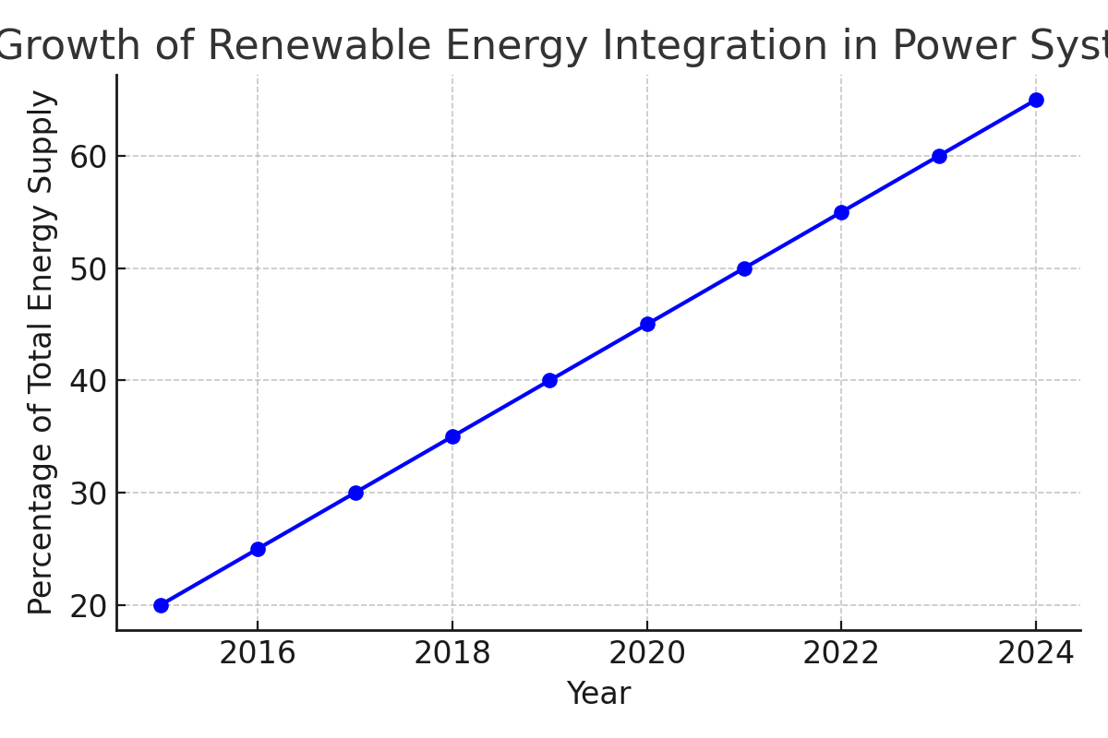

**Figure 1: Renewable Energy Growth with Optimization** This chart demonstrates the impact of optimization techniques on renewable energy adoption over time. The research paper emphasizes the importance of optimization for scaling IoT systems with renewable energy sources, as seen by the growth in energy contribution over the years when using advanced power flow optimization techniques.